Install Netbackup 6.5 client. This is to use S640001 as the master server and S640002 as a media server. All other settings are default. A copy of this can be found at \\ukdterm2\c$\Netbackup\Netbackup_6-5 Win

Install Netbackup 6.5.5 update. All defaults in the installation are to be used. A copy of this can be found at \\ukdterm2\c$\Netbackup\Netbackup_6-5-5 Win x86

Open up the Netbackup Backup, Archive and Restore client from the server. Change the Netbackup Machines and Policy Type as follows:

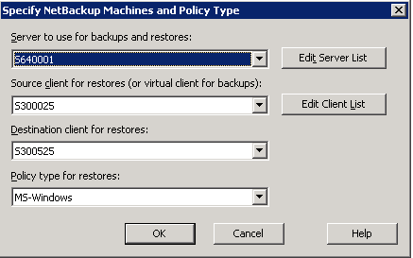

Select the appropriate backup you wish to restore from and tick all the drives as options to restore

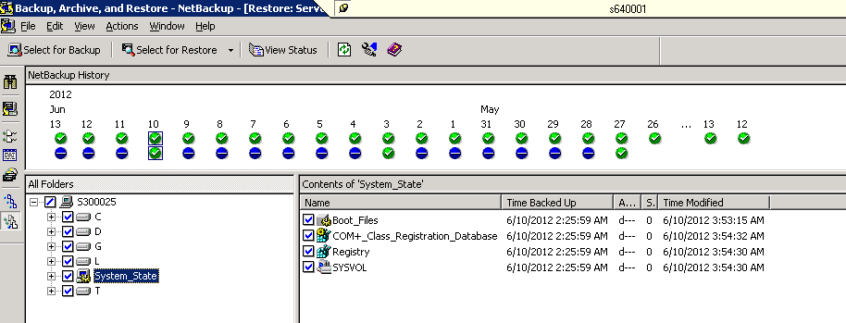

Click Actions -> Restore. Select to overwrite existing files and then click Restore.

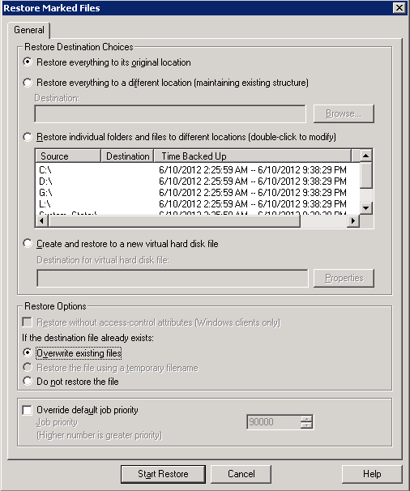

Wait for restore to finish. Then go to C:\SQL 2000 Installation\x86 folder. Right click over DATA folder and select properties. Untick Read-Only if applicable.

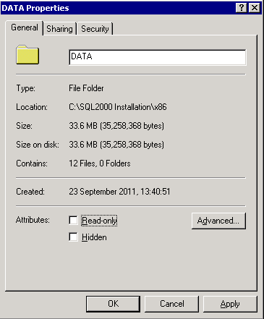

Select to apply changes to this folder, subfolders and files and click OK.

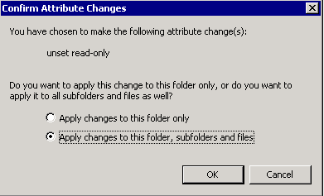

Double click on C:\Program Files\Microsoft SQL Server\80\Tools\Binn\rebuildm.exe. Put settings in as below and click Rebuild.

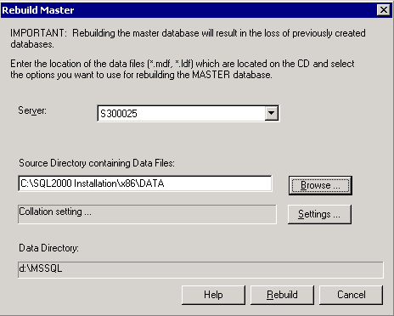

Click Yes



Click OK

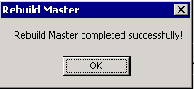

Run this from command line

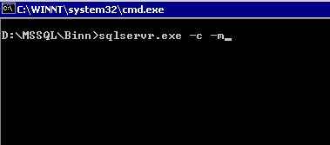

Once it says SQL Server is ready for client connections, then you can start restoring the databases

